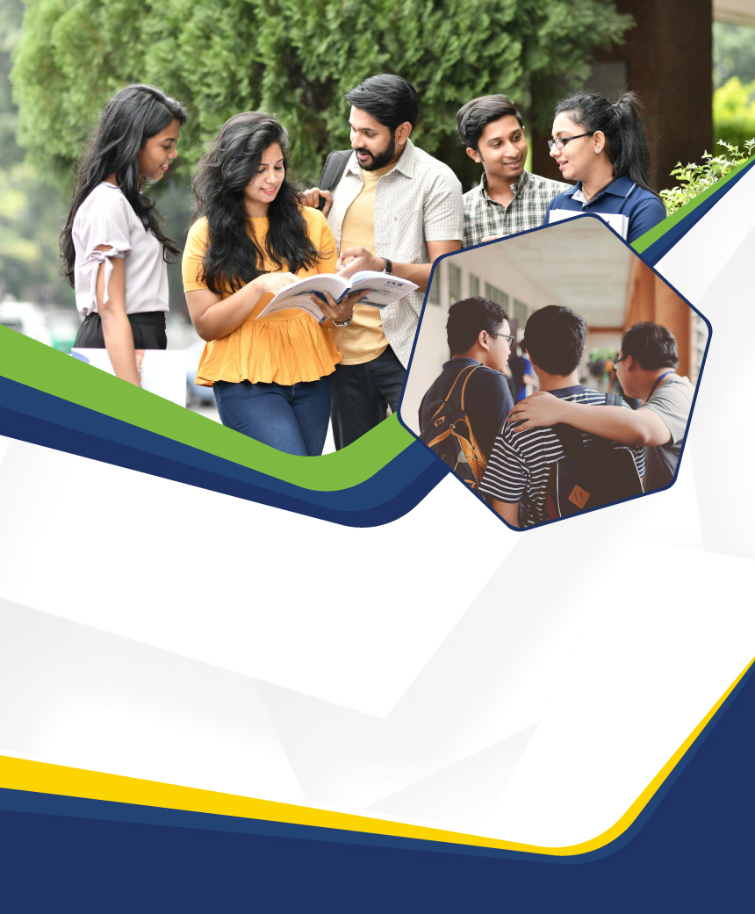

**Disclaimer: The content is curated from online/offline resources and used for educational purpose only**



**LAB MANUAL**

**Unit VII – Understanding the Gen AI Application**

**Unit VII – Understanding the Gen AI Application (chat GPT), and other Gen AI Applications (ChatGPT, Adobe Express, Black Box AI)**

**Lab - 1**

**Lab Objectives:**

* Understand various Gen AI applications for code, image, and animation generation.
* Use AI tools like ChatGPT, Adobe Express, and Black Box AI to generate outputs based on specific prompts.
* Reflect on the potential and limitations of AI-driven tools for creative and technical tasks.

**Pre-requisites:**

* Basic knowledge of Python programming, HTML/CSS, and image generation.
* Familiarity with online AI tools and code editors.

**Lab Exercises:**

**Exercise 1: Animation Generation Using ChatGPT and Pygame**

**Generating an Animation of an Elastic Ball Using Pygame with ChatGPT**

**Objective:**

The objective of this lab is to utilize ChatGPT to generate Python code that creates an animation of an elastic ball dropping from a height and bouncing when it touches the ground using the Pygame library. Additionally, this lab aims to demonstrate how to execute the generated code to visualize the animation.

**Equipment Required:**

1. Computer with internet access
2. Python installed
3. Pygame library
4. Text editor or integrated development environment (IDE)

**Prerequisites:**

1. Basic understanding of Python programming language
2. Familiarity with basic physics concepts such as gravity and velocity
3. Basic knowledge of using ChatGPT for code generation

**Problem Statement:**

Write a Python program that simulates the motion of an elastic ball falling from a height and bouncing when it hits the ground.

**Procedure:**

Setting up the Environment:

1. Ensure that Python is installed on your computer. You can download it from the official Python website: https://www.python.org/downloads/
2. Install the Pygame library by running the following command in your terminal or command prompt: *pip install pygame*

**Accessing ChatGPT:**

Access a platform or interface where ChatGPT is available. This can be through OpenAI's API, a chat application integrated with GPT, or an online demo provided by OpenAI.

**Interacting with ChatGPT:**

Describe the problem statement to ChatGPT clearly and concisely. For example:

*"I want to create a Python program that generates an animation of an elastic ball dropping from a height and bouncing when it touches the ground using the Pygame library. Can you help me with the code?"*

Engage in a conversation with ChatGPT, providing any additional context or details it might ask for to ensure a better understanding of the problem.

**Executing the Generated Code:**

Copy the generated Python code from the chat interface and paste it into a text editor or IDE.

Save the file with an appropriate name and a .py extension (e.g., elastic_ball_animation.py) in your desktop.

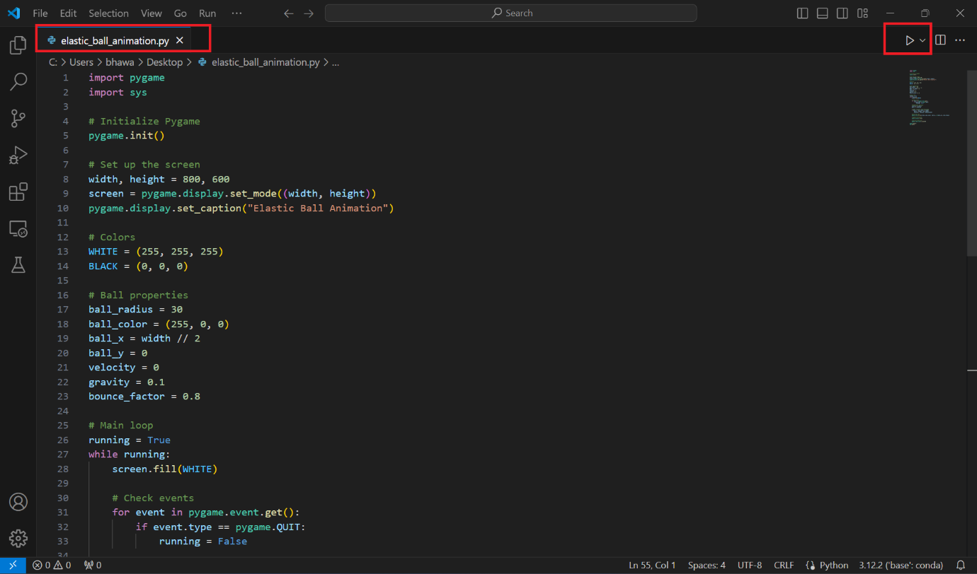

Run the Python script in your terminal or command prompt:

Steps:

1. Open Terminal or CMD
2. Change the location using cd to your desktop location: *cd Desktop*
3. To execute the program write : *python elastic_ball_animation.py* and then hit enter.
4. Double click the below video to play.



Observe the Pygame window that opens, displaying the animation of the elastic ball dropping from a height and bouncing when it hits the ground.

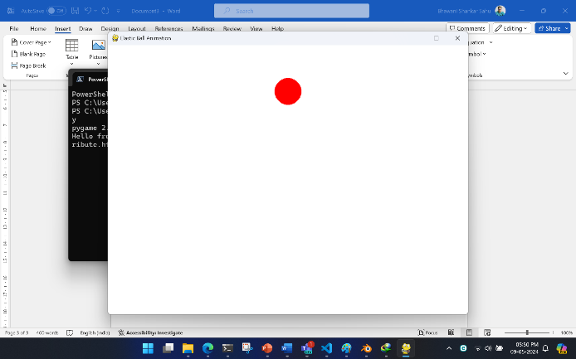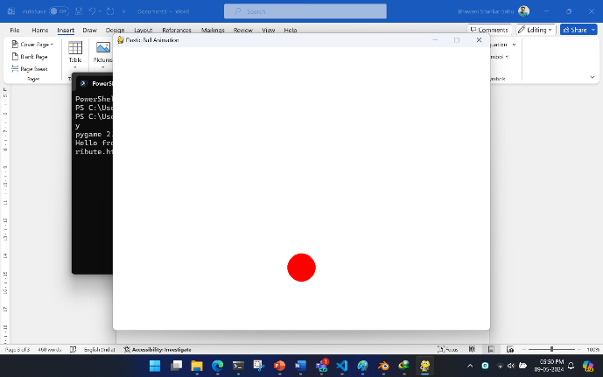

**Exploring and Experimenting:**

After running the code, experiment with different parameters such as initial velocity, gravity, and bounce factor to observe their effects on the animation.

Modify the code generated by ChatGPT or add additional features to enhance the animation further, such as adding multiple balls or changing the background color.

**Conclusion:**

Reflect on the process of using ChatGPT to generate code and visualize the animation. Consider the advantages and limitations of this approach compared to writing code manually.

Explore further possibilities for using ChatGPT to automate code generation for other programming tasks or projects.

**Exercise 2: Image Generation Using Adobe Express Text to Image Tool**

**Objective**:

The objective of this lab is to use Adobe Express Text to Image Tool to generate an image based on a given prompt. Specifically, the task is to create an image of a girl talking to an advanced robot in a forest during sunset.

**Equipment Required:**

1. Computer with internet access
2. Web browser
3. Adobe Express Text to Image Tool (available online)

**Prerequisites**:

1. Basic understanding of image generation tools and techniques
2. Familiarity with Adobe Express Text to Image Tool interface
3. Creative visualization skills

**Problem Statement:**

Generate an image of a girl talking to an advanced robot in a forest during sunset using Adobe Express Text to Image Tool.

**Procedure:**

Accessing Adobe Express Text to Image Tool:

Open your web browser and navigate to the Adobe Express Text to Image Tool website. You can search for it using your preferred search engine.

Link: [Generate an image from text using generative AI (adobe.com)](https://helpx.adobe.com/in/express/using/text-to-image.html)

Login to this platform using google account.

Understanding the Prompt:

Carefully read and visualize the prompt: "Generate an image of a girl talking to an advanced robot in a forest during sunset." Imagine the scene in your mind and consider the elements that should be included in the image, such as the girl, the robot, trees, sunset lighting, etc.

Inputting the Prompt:

Once on the Adobe Express Text to Image Tool website, locate the input field or text box where you can enter your prompt.

Type or paste the prompt "*Generate an image of a girl talking to an advanced robot in a forest during sunset*" into the input field.

**Generating the Image:**

After entering the prompt, initiate the image generation process by pressing the "Generate" button.

Adobe Express Text to Image Tool will use artificial intelligence (AI) algorithms to interpret the prompt and generate an image based on the provided text.

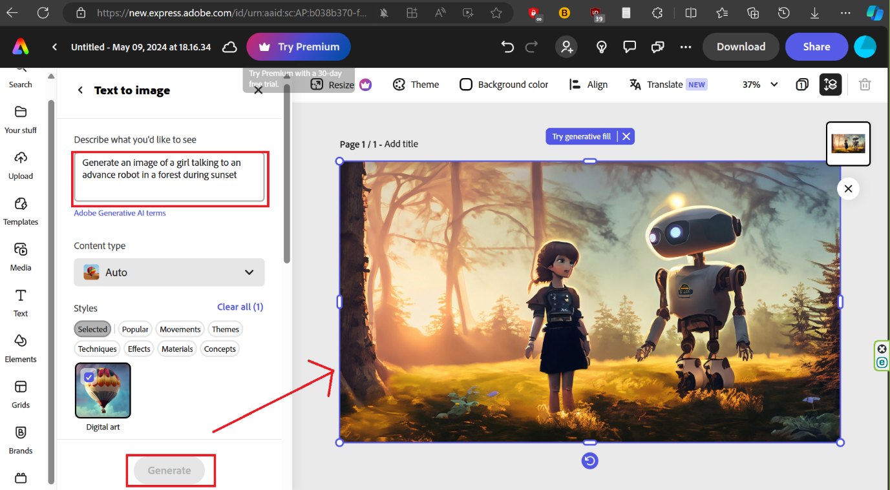

**Experimentation and Exploration:**

Experiment with different variations of the prompt or input additional details to see how they influence the generated image.

Explore other features and functionalities of Adobe Express Text to Image Tool to create different types of images or scenes.

**Conclusion:**

Reflect on the process of using Adobe Express Text to Image Tool to generate an image based on a given prompt. Consider the advantages and limitations of AI-driven image generation tools in creative projects.

Discuss potential applications of such tools in various fields, including graphic design, storytelling, and content creation.

**Exercise 3: HTML/CSS Code Generation Using Black Box AI**

**Objective:**

The objective of this lab is to utilize Black Box AI to generate HTML and CSS code for a basic webpage. The lab aims to demonstrate how to use the output from Black Box AI to create a simple webpage structure with styling.

**Equipment Required:**

1. Computer with internet access
2. Web browser
3. Black Box AI (available online)

**Prerequisites:**

1. Basic understanding of HTML and CSS
2. Familiarity with web development concepts such as webpage structure, tags, and styling properties
3. Creative thinking and problem-solving skills

**Problem Statement:**

Generate HTML and CSS code for a basic webpage using Black Box AI.

**Procedure:**

Accessing Black Box AI:

Open your web browser and navigate to the Black Box AI website. You can search for it using your preferred search engine.

Understanding the Task:

Familiarize yourself with the task of generating code for a basic webpage using Black Box AI. Understand that the AI will interpret your input and generate HTML and CSS code accordingly.

Inputting the Task:

Once on the Black Box AI website, locate the input field or text box where you can enter your task.

Describe the task clearly and concisely. For example:

"*Generate HTML and CSS code for a basic webpage with a header, navigation menu, content section, and footer*."

**Generating the Code:**

Initiate the code generation process by submitting your task to Black Box AI. Look for a button or option to start the generation process.

Black Box AI will analyze your input and generate HTML and CSS code for a basic webpage structure based on the provided description.

**Reviewing the Generated Code:**

Once the code generation process is complete, review the generated HTML and CSS code. Examine the structure, tags, and styling properties included in the code.

Pay attention to how well the generated code aligns with your description of the webpage structure. Evaluate the readability and organization of the code.

**Saving the Code:**

If satisfied with the generated code, use the options provided by Black Box AI to save or copy the HTML and CSS code to your computer's clipboard.

Alternatively, download the generated code as a text file for later use.

**Creating the Webpage:**

Open a text editor or integrated development environment (IDE) to create a new file for the webpage.

Paste the generated HTML and CSS code into the appropriate sections of the file, separating the HTML and CSS code into their respective blocks.

Save the file with an appropriate name and a .html extension (e.g., basic_webpage.html).

**Previewing the Webpage:**

Open the saved HTML file in your web browser to preview the webpage. You should see a basic webpage structure with the header, navigation menu, content section, and footer as described in the generated code.

Adjust the content and styling properties in the HTML and CSS code as needed to customize the appearance and layout of the webpage.

**Conclusion:**

Reflect on the experience of using Black Box AI to generate HTML and CSS code for a basic webpage. Consider the advantages and limitations of AI-driven code generation tools in web development.

Discuss potential applications of such tools in various aspects of web development, including prototyping, rapid iteration, and code scaffolding.

**Exercise 4:** [D-ID Creative Reality Studio](https://studio.d-id.com/)

**Overview**

D-ID Creative Reality Studio is a platform that combines advanced generative AI tools for creating digital avatars and video content using text, images, and speech input. This lab manual will guide you through using D-ID Creative Reality Studio to generate dynamic, AI-driven videos featuring lifelike avatars.

**Objectives**

* To understand the core functionalities of D-ID Creative Reality Studio.
* To create, customize, and animate digital avatars using text-to-video

**Prerequisites**

* Basic understanding of AI and generative models.
* A D-ID Creative Reality Studio account (free or paid).
* Internet connection and a computer with a modern web browser.

**Lab Equipment & Tools**

* **Computer:** A laptop or desktop with a stable internet connection.
* **Browser:** Chrome, Firefox, or any modern browser.
* **D-ID Creative Reality Studio Access:** Sign up at [D-ID](https://www.d-id.com/).

**Let’s start**

**1. Getting Started with D-ID Creative Reality Studio**

**Steps:**

1. **Log In:** Visit [D-ID Creative Reality Studio](https://www.d-id.com/) and log in or sign up for an account.
2. **Explore the Dashboard:** Familiarize yourself with the interface. The main sections include options for creating new projects, uploading images, and managing completed projects.
3. **Create a Video:** Click on “Create a video” to start a new text-to-video or speech-to-video project.

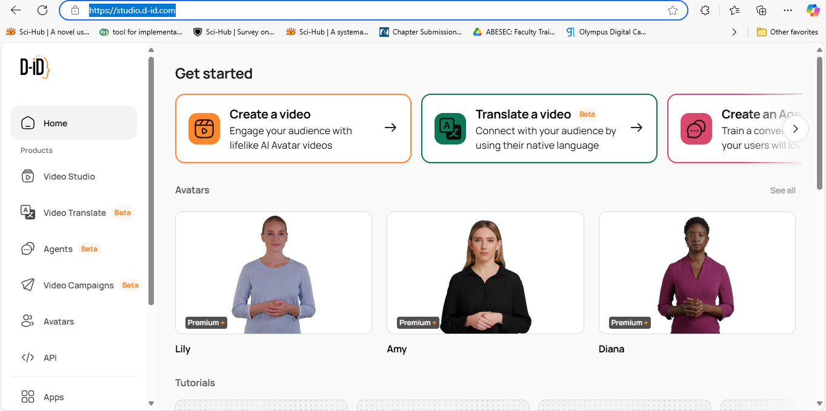

Login with your google account

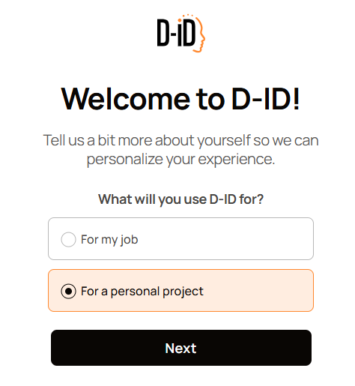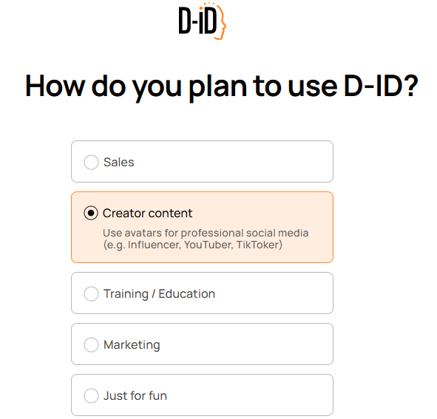

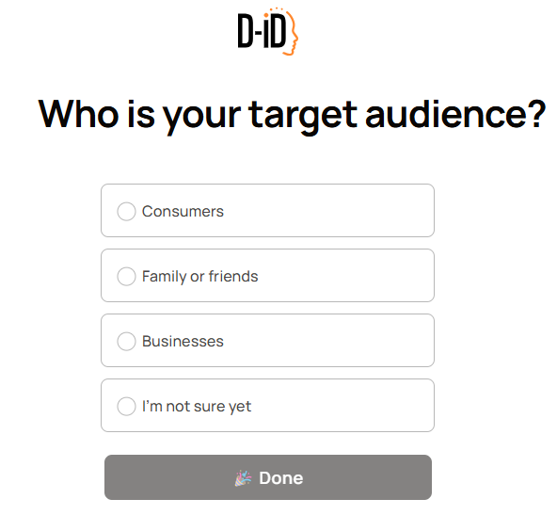

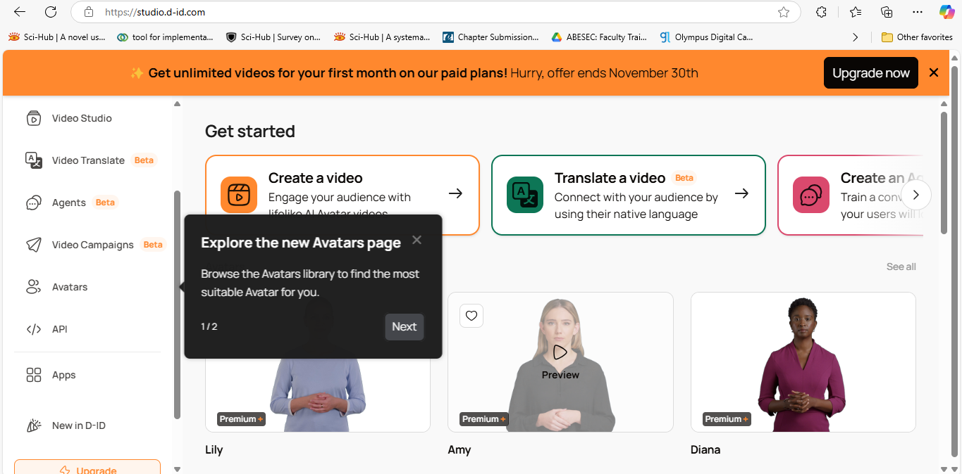

**2. Creating an Avatar-Based Video**

**Steps:**

1. **Select Avatar Type:**
   * Choose from available avatars or upload a custom image to create a personalized avatar.
   * Adjust avatar settings, such as positioning or expression.
2. **Add Text or Speech Input:**
   * For **text-to-video**: Type a script that the avatar will narrate.
   * For **speech-to-video**: Upload or record a voiceover that the avatar will lip-sync.
3. **Configure Voice Settings:**
   * Choose a voice style, language, and accent (if using text-to-speech).
   * Adjust the voice speed and tone if required.
4. **Preview the Output:**
   * Click on “Preview” to see how the avatar performs. Adjust as needed to ensure smooth lip-syncing and realistic avatar motion.
5. **Finalize Video Settings:**
   * Add background music, captions, or any additional settings provided in the platform.
   * Set the video duration and export quality.

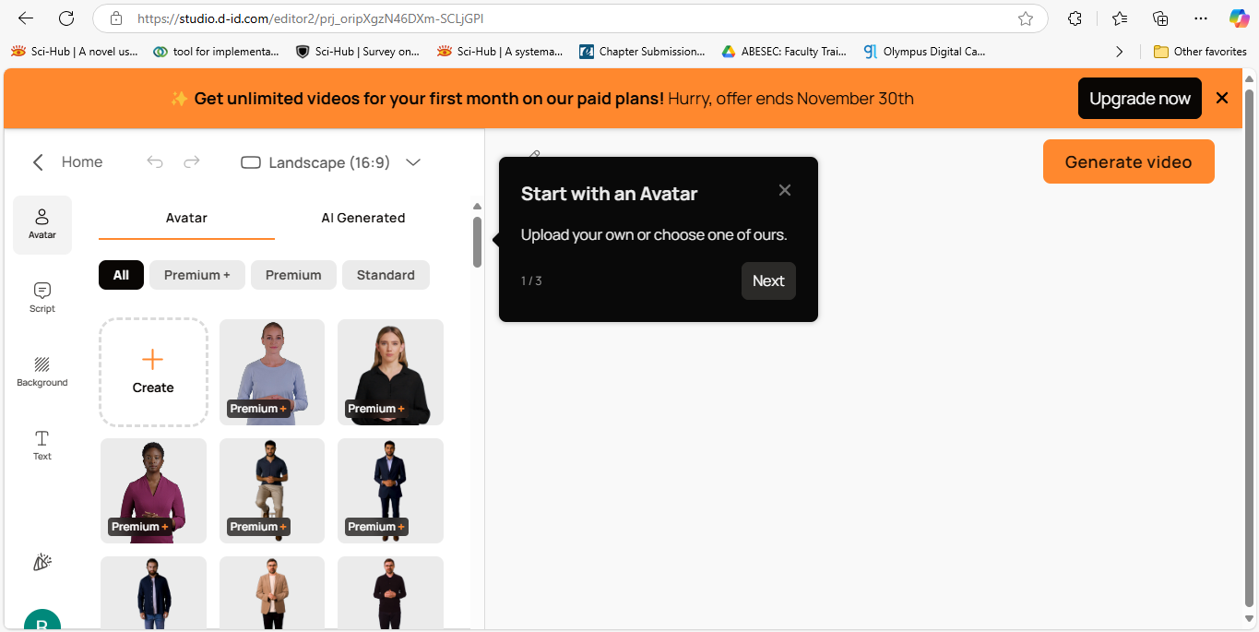

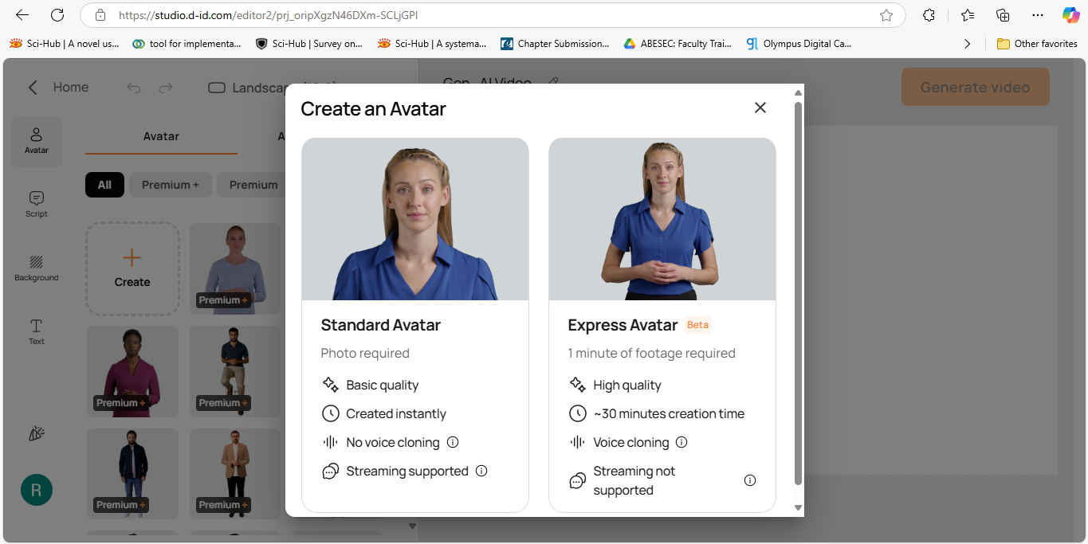

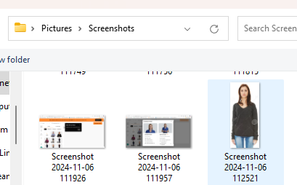

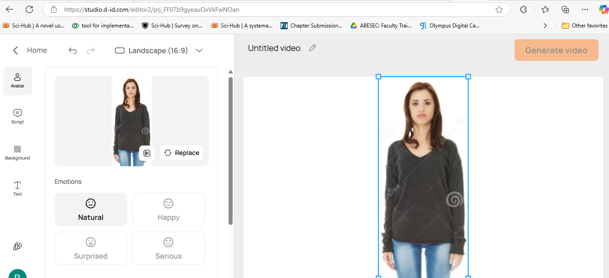

Add the script and click on Generate Video

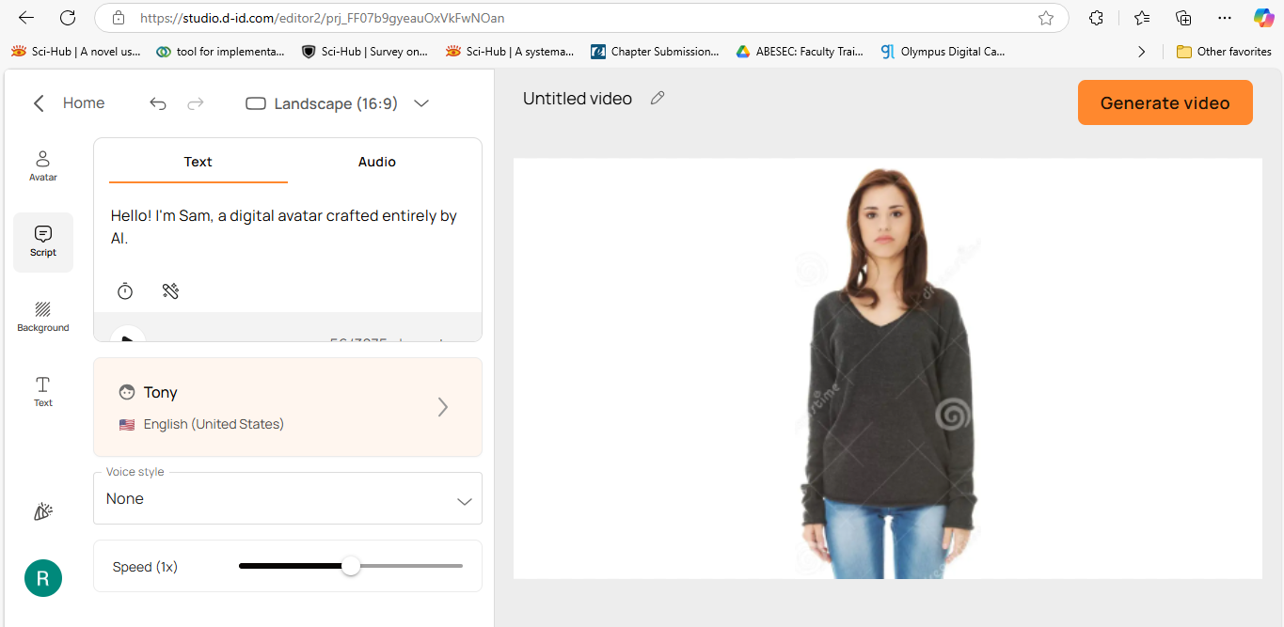

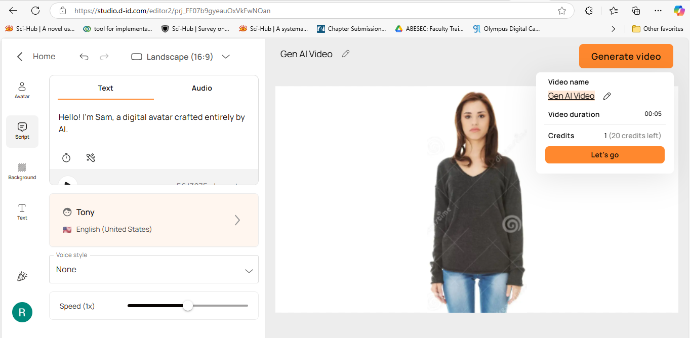

<https://studio.d-id.com/share?id=233cbe114606cfddf6187bb175925bf2&utm_source=copy>

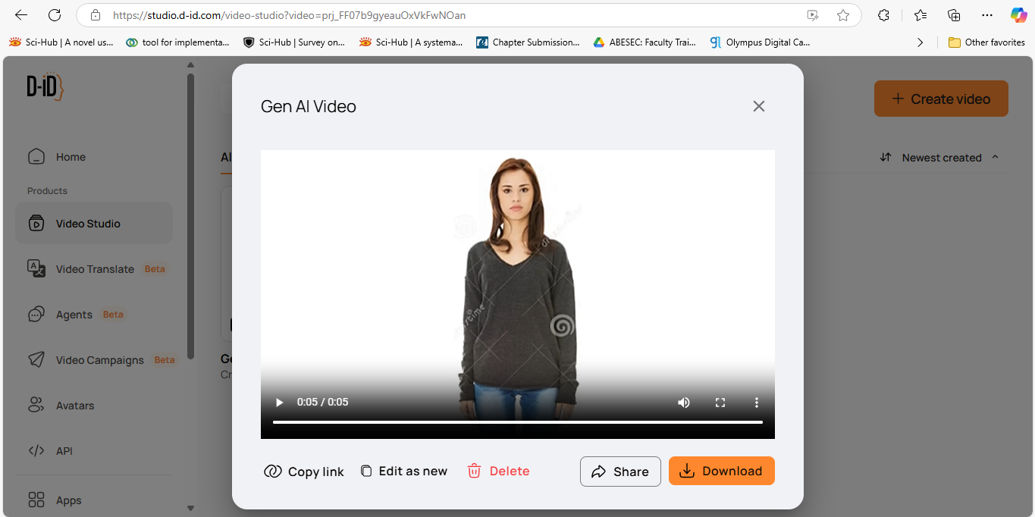

**Conclusion**

D-ID Creative Reality Studio offers powerful generative tools for creating AI-driven, realistic avatars. By following these steps, you’ll gain hands-on experience in producing high-quality, interactive videos that can be applied in various fields such as education, marketing, and entertainment.

**Exercise 5**: **Getting Started with Runway ML**

**Objective:**

Learn how to use Runway ML for creative AI tasks such as generating images, videos, or text using pre-trained machine learning models.

**Prerequisites:**

* A computer with internet access.
* A browser (Chrome, Firefox, etc.).
* A Runway ML account (Sign up at [Runway ML](https://runwayml.com/)).

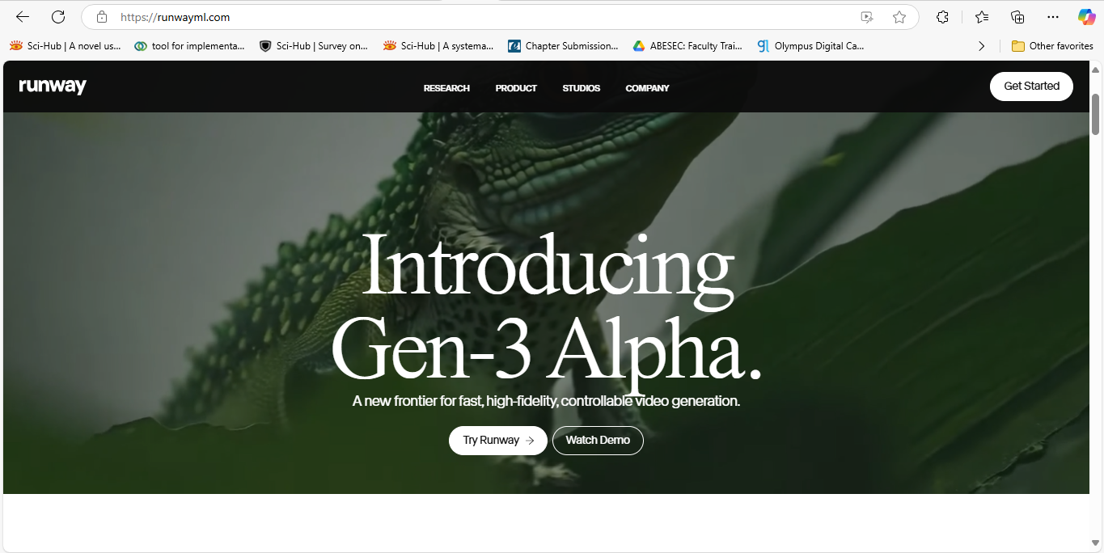

**Step-by-Step Instructions:**

**Step 1: Create a Runway ML Account**

1. Go to the [Runway ML website](https://runwayml.com/).
2. Click on **Sign Up** at the top right corner to create a new account.
3. Follow the instructions to sign up using your email or other social logins.
4. Once signed up, log in to your account.

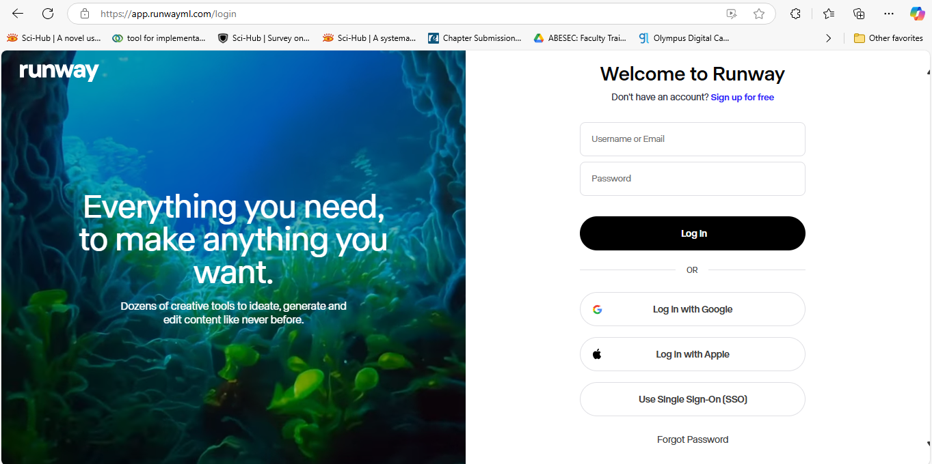

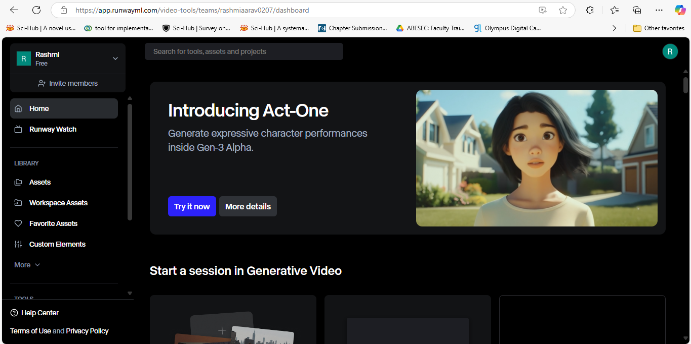

**Step 2: Explore the Runway Dashboard**

1. After logging in, you will land on the **Runway Dashboard**.
2. Here, you can see a variety of **models** available for use. These models cover areas like **image generation, text-to-image, video editing, and more**.
3. Take some time to explore the available models and get familiar with the interface.

**Step 3: Create a New Project**

1. Click on **Create New Project** or **New Workspace**.
2. Choose the type of project you want to work on (e.g., Image Generation, Text Generation, Video Processing).
3. Give your project a name (e.g., "AI Art Project") and click **Create Project**.

**Step 4: Add a Model to Your Project**

1. Once inside your project, click on **Add Model**.
2. You’ll see a list of models for different tasks. Some popular models include:
   * **BigGAN** for image generation
   * **GPT-3** for text generation
   * **Stable Diffusion** for advanced image generation
3. Select the model that fits your creative task (e.g., **BigGAN** for image generation).
4. Click **Add to Workspace** to add it to your project.

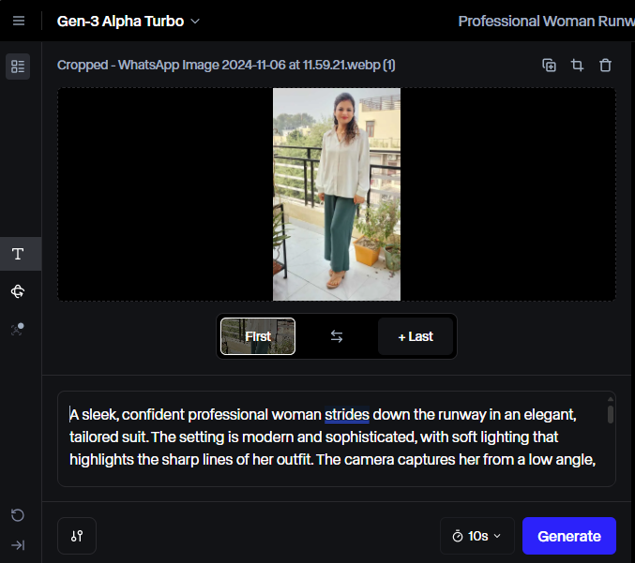

**Step 5: Configure the Model**

1. After adding a model, you will see a configuration screen.
2. For example, if you added the **BigGAN** model for generating images, you can adjust parameters such as:
   * **Input Prompt**: The text or settings you provide to guide the model’s output.
   * **Style**: Choose different styles or variations for the generated images.
3. Adjust the parameters to suit your needs, then click **Run** to generate the output.

**Step 6: Generate Your Output**

1. Once the model is configured, click on **Run**.
2. Wait for the model to process and generate the output (this may take a few seconds to a couple of minutes depending on the model and the complexity of the task).
3. Once completed, you will see the generated output. For example, images generated by **BigGAN** will appear in the output section.

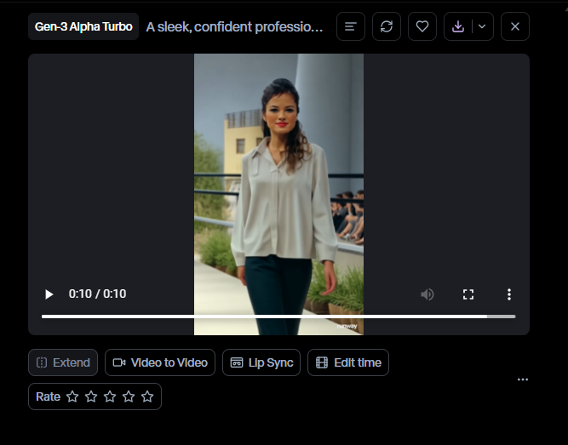

**Step 7: Save or Export Your Results**

1. After the output is generated, you can save or export the result.
2. Click on **Save** to store it in your project.
3. To export, click on **Export** and choose your preferred format (e.g., download the image or text as a file).
4. You can also directly share your result or embed it on other platforms if needed.

### **Self-Exercise:**

Generate Audio from the text

Step 1: Select Generative Audio

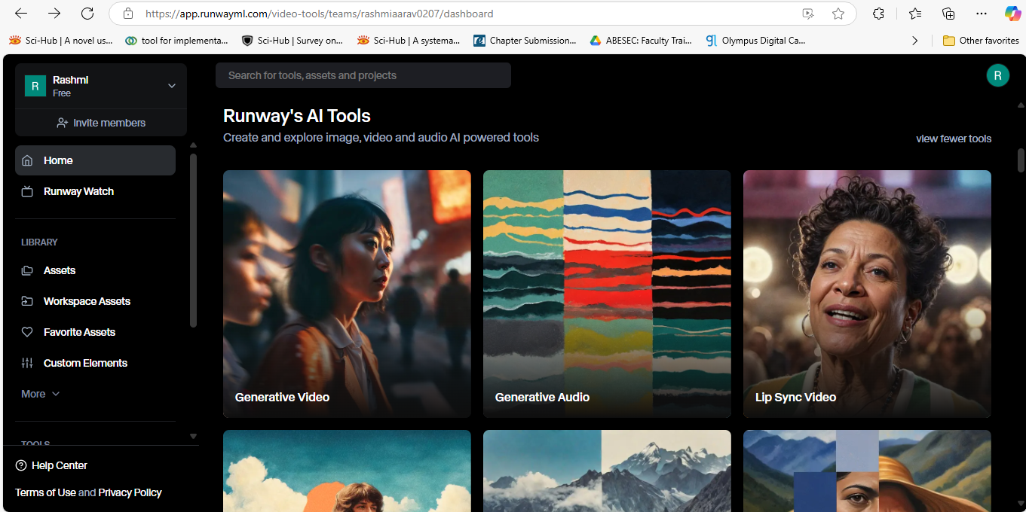

Step 2: Add some text

### 

Click on Generate

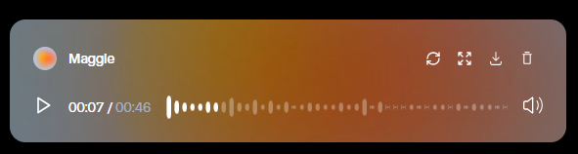

### **Conclusion:**

You have successfully created and run a creative AI project using **Runway ML**. You have learned how to add models, configure them, and generate creative outputs such as images or text. With Runway ML, you can continue to explore advanced AI models and push the boundaries of creative possibilities.